M KARTHIKEYAN

727721EUIT070

***CIA-2***

COADING:

**package** CIA2;

**import** java.util.List;

**import** org.openqa.selenium.By;

**import** org.openqa.selenium.WebDriver;

**import** org.openqa.selenium.WebElement;

**import** org.openqa.selenium.chrome.ChromeDriver;

**import** org.openqa.selenium.chrome.ChromeOptions;

**import** org.testng.AssertJUnit;

**import** org.testng.annotations.Test;

**import** io.github.bonigarcia.wdm.WebDriverManager;

**public** **class** CIA2QUESTION1 {

@Test

**public** **void** f()**throws** InterruptedException {

WebDriverManager.*chromedriver*().setup();

WebDriver driver;

ChromeOptions co = **new** ChromeOptions();

co.addArguments("--remote-allow-origins=*");

driver=**new** ChromeDriver(co);

driver.manage().window().maximize();

driver.get("https://www.trivago.in/");

Thread.*sleep*(2000);

String actualTitle="trivago.in - Compare hotel prices worldwide";

String extractedTitle=driver.getTitle();

AssertJUnit.*assertEquals*(actualTitle, extractedTitle);

System.***out***.println("Page title is Validated.");

Thread.*sleep*(2000);

WebElement location=driver.findElement(By.*xpath*("//*[@id=\"__next\"]/div[1]/div[1]/section/div[2]/div[3]/div/div[1]/div/form/div"));

location.click();

Thread.*sleep*(2000);

WebElement ben=driver.findElement(By.*xpath*("//*[@id=\"suggestion-list\"]/ul/li[1]/div/div"));

ben.click();

Thread.*sleep*(2000);

WebElement cin=driver.findElement(By.*xpath*("//*[@id=\"__next\"]/div[1]/div[1]/section/div[2]/div[3]/div/div[2]/div/div/div/div[2]/div/div[1]/div[2]/button[2]/time"));

cin.click();

Thread.*sleep*(2000);

// WebElement coutcol=driver.findElement(By.xpath("//*[@id=\"__next\"]/div[1]/div[1]/section/div[2]/div[3]/div/div[1]/fieldset/button[2]/span"));

// coutcol.click();

WebElement cout=driver.findElement(By.*xpath*("//*[@id=\"__next\"]/div[1]/div[1]/section/div[2]/div[3]/div/div[2]/div/div/div/div[2]/div/div[1]/div[2]/button[7]/time"));

cout.click();

Thread.*sleep*(2000);

WebElement inc=driver.findElement(By.*xpath*("//*[@id=\"__next\"]/div[1]/div[1]/section/div[2]/div [3]/div/div[2]/div/div/div[1]/div/div[1]/div[1]/div/button[2]/span/span[1]"));

inc.click();

inc.click();

inc.click();

Thread.*sleep*(2000);

WebElement pet=driver.findElement(By.*id*("checkbox-13"));

pet.click();

Thread.*sleep*(3000);

WebElement apply=driver.findElement(By.*xpath*("//*[@id=\"__next\"]/div[1]/div[1]/section/div[2]/div[3]/div/div[2]/div/div/div[2]/div/button[2]"));

apply.click();

Thread.*sleep*(3000);

**if**(driver.getTitle().equals("Bengaluru (Pet friendly) Hotels | Find & compare great deals on trivago")) {

System.***out***.println("1.Verified that the user can enter the location of stay.");

System.***out***.println("2.Verified that the user can select the check-in and check-out date.");

System.***out***.println("3.Verified that the user can enter the no of rooms based on their preference.");

}

// WebElement kp=driver.findElement(By.id("//*[@id=\"sorting-selector\"]"));

// kp.click();

// List<WebElement>li=driver.findElements(By.xpath("//*[@id=\"__next\"]/div[1]/main/div[5]/section/div/div/ol/li[1]/div/article/div[2]/div[1]/section/h2/button/span"));

// for(WebElement link:li) {

// System.out.println(link.getText());

// }

}

**}**

**OUTPUT:**

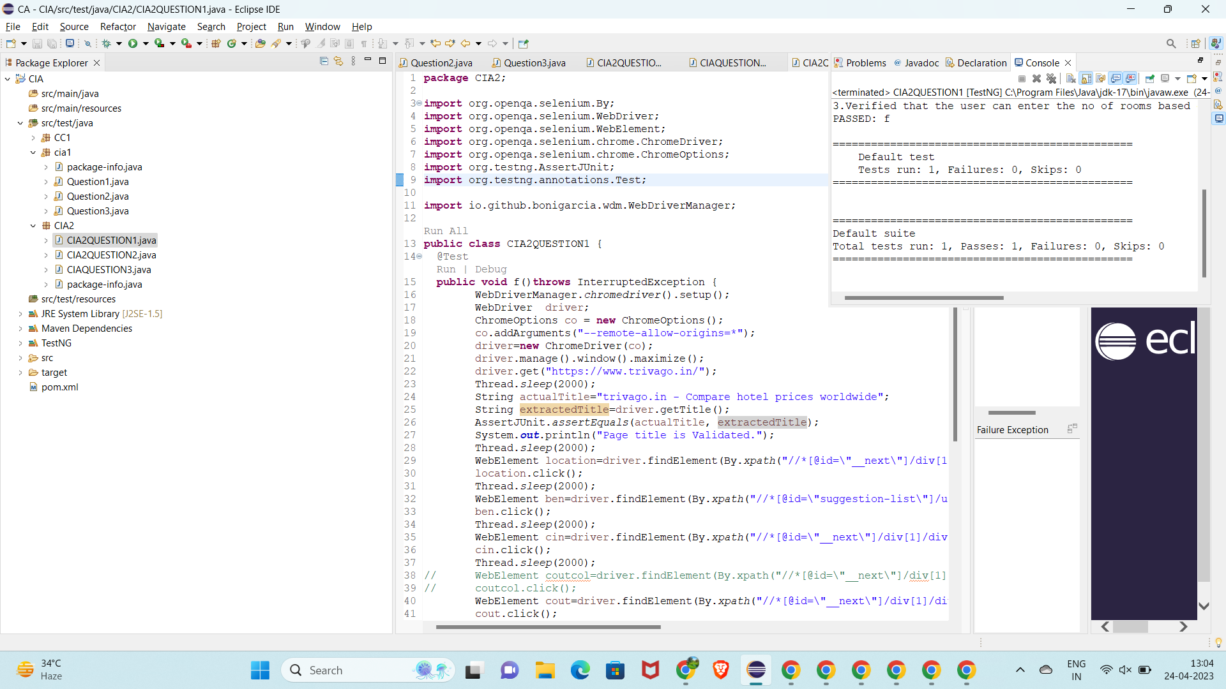

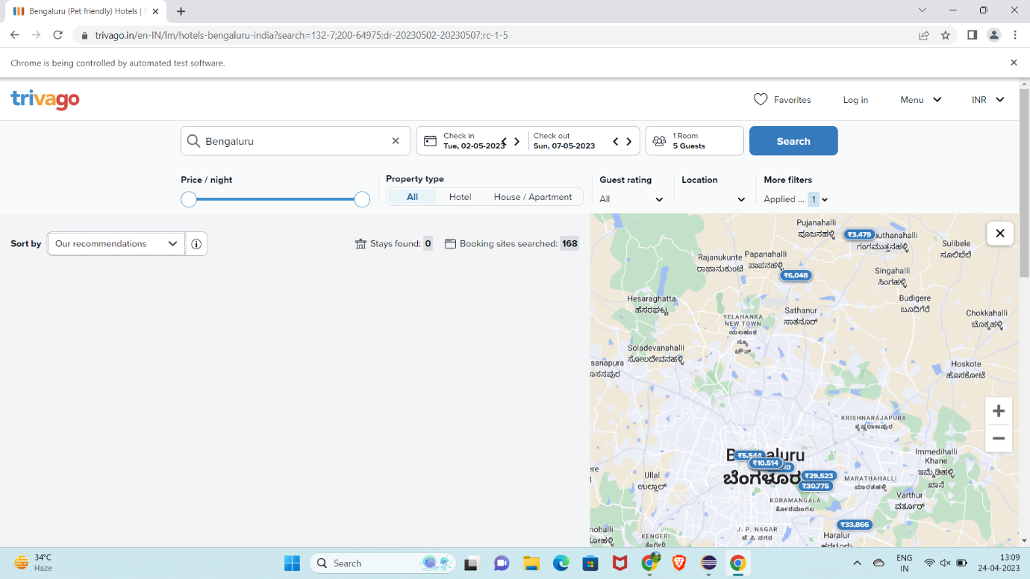

**package** CIA2;

**import** org.openqa.selenium.By;

**import** org.openqa.selenium.WebDriver;

**import** org.openqa.selenium.chrome.ChromeDriver;

**import** org.openqa.selenium.chrome.ChromeOptions;

**import** org.testng.annotations.Test;

**import** io.github.bonigarcia.wdm.WebDriverManager;

**public** **class** CIA2QUESTION2 {

@Test

**public** **void** f() **throws** InterruptedException {

WebDriverManager.*chromedriver*().setup();

ChromeOptions co = **new** ChromeOptions();

co.addArguments("--remote-allow-origins=*");

WebDriver driver=**new** ChromeDriver(co);

driver.get("https://www.trivago.in/en-IN/lm/cheap-hotels-bengaluru-india?search=132-7;200-64975;dr-20230502-20230507;rc-1-5;so-4");

driver.manage().window().maximize();

driver.findElement(By.*xpath*("//*[@id=\"__next\"]/div[1]/div[1]/section/div[2]/div[3]/ul/li[2]/span/label")) .click();

driver.findElement(By.*xpath*("//*[@id=\"__next\"]/div[1]/div[1]/section/div[2]/div[3]/div/div[1]/div/form")).click();

driver.findElement(By.*xpath*("//*[@id=\"suggestion-list\"]/ul/li[1]/div/div")) .click();

Thread.*sleep*(100);

driver.findElement(By.*xpath*("//*[@id=\"__next\"]/div[1]/div[1]/section/div[2]/div[3]/div/div[1]/fieldset/button[1]/span/span[2]/span[2]")) .click();

driver.findElement(By.*xpath*("//*[@id=\"__next\"]/div[1]/div[1]/section/div[2]/div[3]/div/div[2]/div/div/div/div[2]/div/div[1]/div[2]/button[2]/time")).click();

driver.findElement(By.*xpath*("//*[@id=\"__next\"]/div[1]/div[1]/section/div[2]/div[3]/div/button")).click();

Thread.*sleep*(10000);

WebElement h1= driver.findElement(By.*xpath*(""));

driver.findElement(By.*xpath*("//*[@id=\"sorting-selector\"]")).click();

driver.findElement(By.*xpath*("//*[@id=\"sorting-selector\"]")).click();

}

}

**OUTPUT:**

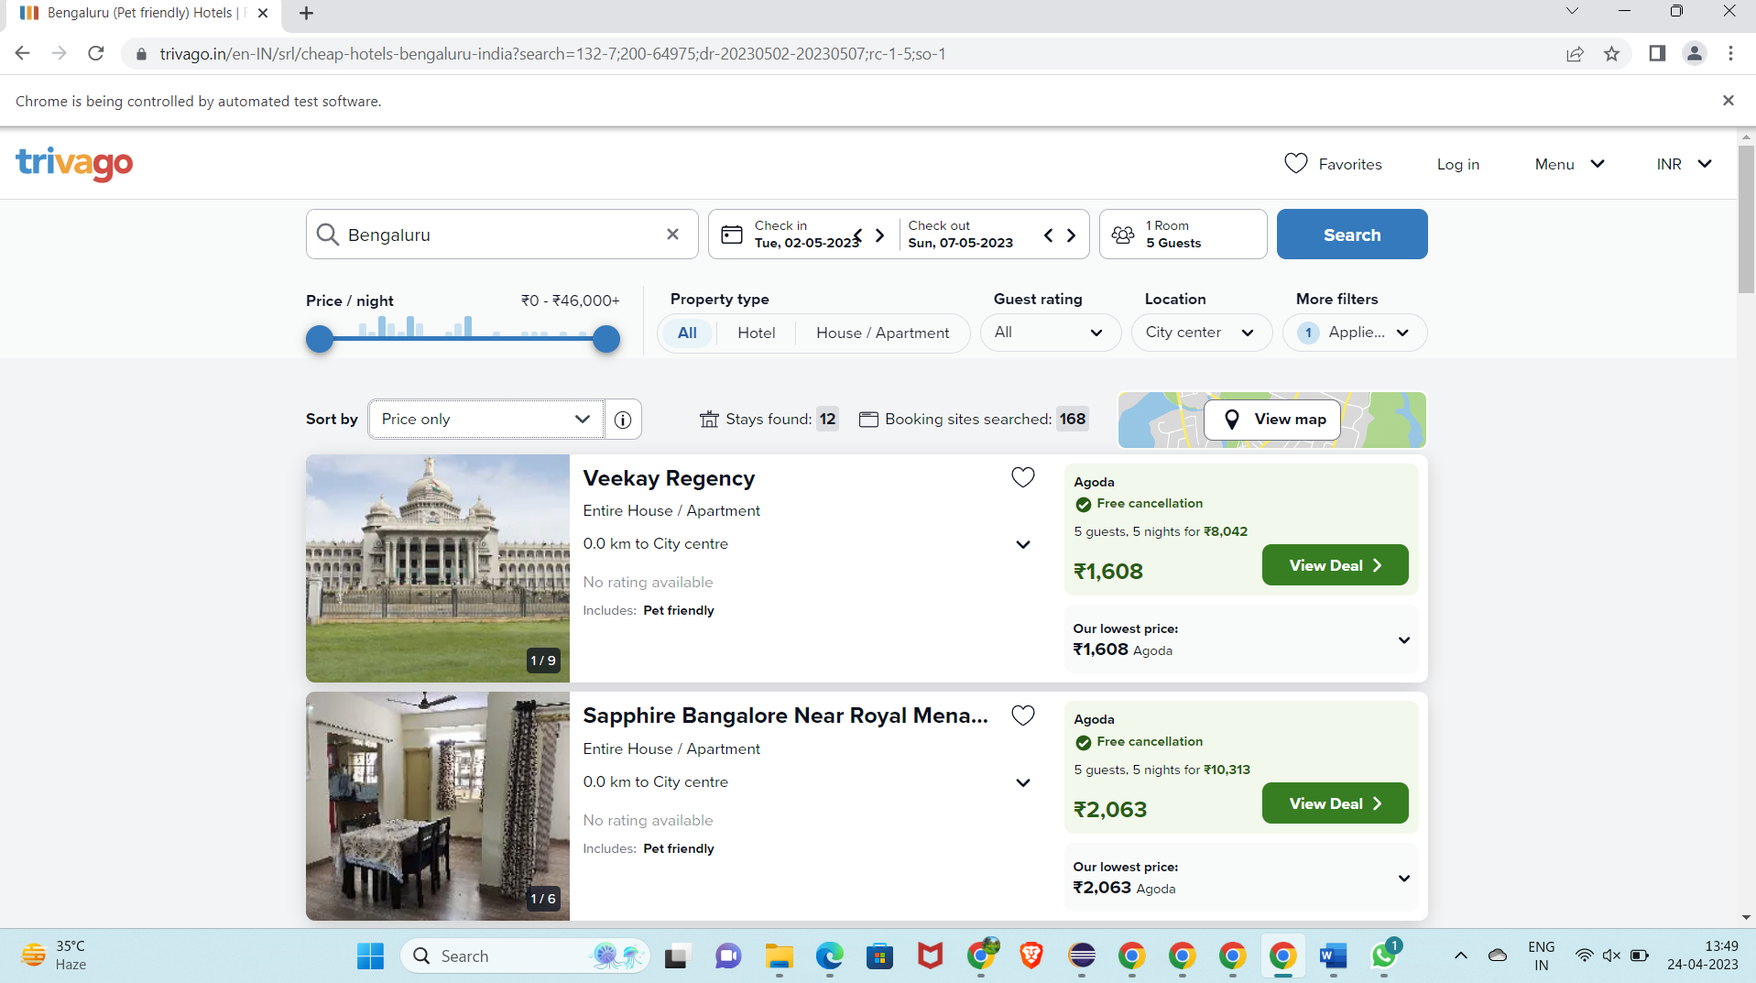

**COADING:**

**package** CIA2;

**import** java.util.List;

**import** org.openqa.selenium.By;

**import** org.openqa.selenium.WebDriver;

**import** org.openqa.selenium.WebElement;

**import** org.openqa.selenium.chrome.ChromeDriver;

**import** org.openqa.selenium.chrome.ChromeOptions;

**import** org.testng.AssertJUnit;

**import** org.testng.annotations.Test;

**import** io.github.bonigarcia.wdm.WebDriverManager;

**public** **class** CIA2QUESTION3 {

@Test

**public** **void** f()**throws** InterruptedException {

WebDriverManager.*chromedriver*().setup();

WebDriver driver;

ChromeOptions co = **new** ChromeOptions();

co.addArguments("--remote-allow-origins=*");

driver=**new** ChromeDriver(co);

driver.manage().window().maximize();

driver.get("https://www.trivago.in/");

Thread.*sleep*(2000);

String actualTitle="trivago.in - Compare hotel prices worldwide";

String extractedTitle=driver.getTitle();

AssertJUnit.*assertEquals*(actualTitle, extractedTitle);

System.***out***.println("Page title is Validated.");

Thread.*sleep*(2000);

WebElement location=driver.findElement(By.*xpath*("//*[@id=\"__next\"]/div[1]/div[1]/section/div[2]/div[3]/div/div[1]/div/form/div"));

location.click();

Thread.*sleep*(2000);

WebElement ben=driver.findElement(By.*xpath*("//*[@id=\"suggestion-list\"]/ul/li[1]/div/div"));

ben.click();

Thread.*sleep*(2000);

WebElement cin=driver.findElement(By.*xpath*("//*[@id=\"__next\"]/div[1]/div[1]/section/div[2]/div[3]/div/div[2]/div/div/div/div[2]/div/div[1]/div[2]/button[2]/time"));

cin.click();

Thread.*sleep*(2000);

// WebElement coutcol=driver.findElement(By.xpath("//*[@id=\"__next\"]/div[1]/div[1]/section/div[2]/div[3]/div/div[1]/fieldset/button[2]/span"));

// coutcol.click();

WebElement cout=driver.findElement(By.*xpath*("//*[@id=\"__next\"]/div[1]/div[1]/section/div[2]/div[3]/div/div[2]/div/div/div/div[2]/div/div[1]/div[2]/button[7]/time"));

cout.click();

Thread.*sleep*(2000);

WebElement inc=driver.findElement(By.*xpath*("//*[@id=\"__next\"]/div[1]/div[1]/section/div[2]/div [3]/div/div[2]/div/div/div[1]/div/div[1]/div[1]/div/button[2]/span/span[1]"));

inc.click();

inc.click();

inc.click();

Thread.*sleep*(2000);

WebElement pet=driver.findElement(By.*id*("checkbox-13"));

pet.click();

Thread.*sleep*(3000);

WebElement apply=driver.findElement(By.*xpath*("//*[@id=\"__next\"]/div[1]/div[1]/section/div[2]/div[3]/div/div[2]/div/div/div[2]/div/button[2]"));

apply.click();

Thread.*sleep*(3000);

**if**(driver.getTitle().equals("Bengaluru (Pet friendly) Hotels | Find & compare great deals on trivago")) {

System.***out***.println("1.Verified that the user can enter the location of stay.");

System.***out***.println("2.Verified that the user can select the check-in and check-out date.");

System.***out***.println("3.Verified that the user can enter the no of rooms based on their preference.");

}

// WebElement kp=driver.findElement(By.id("//*[@id=\"sorting-selector\"]"));

// kp.click();

// List<WebElement>li=driver.findElements(By.xpath("//*[@id=\"__next\"]/div[1]/main/div[5]/section/div/div/ol/li[1]/div/article/div[2]/div[1]/section/h2/button/span"));

// for(WebElement link:li) {

// System.out.println(link.getText());

// }

}

}